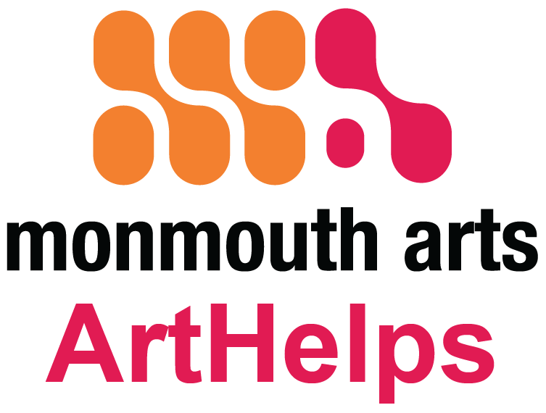
ArtHelps Local Arts Program
FISCAL YEAR 2020 MINI GRANT
January 1, 2020 – December 31, 2020
Monmouth Arts offers $500 Mini Grants for arts projects to new and emerging organizations, and organizations only requiring a small amount of funding as part of the Local Arts Grant Program through the New Jersey State Council on the Arts. Organizations can apply for only one Mini Grant per fiscal year and may not have received other Monmouth Arts funding. These grants have a simplified application process and a short time frame from application to award. There is no deadline. Applications are reviewed every two months.
APPLICATION GUIDELINES
Projects must take place during Fiscal Year 2020 (January 1, 2020 - December 31, 2020). Mini Grants must be matched on a dollar for dollar basis (1:1). See Application Guidelines at www.monmoutharts.org/art-helps-grants for full criteria.
Mini Grants are intended as an introduction to the ArtHelps Local Arts Grant Program, however, organizations only requiring a small amount of funding for their project may continue to apply for Mini Grants in subsequent years. After one successful Mini Grant application organizations can apply through the regular grant process for future support. A grant received in one year is no guarantee of subsequent funding.
Organizations that apply for General Operating Support, General Programming Support, Technical Assistance or Special Project Support through Monmouth Arts or the NJ State Council on the Arts may not apply for a Mini Grant.
Grant recipients must submit a Final Report consisting of a narrative and final financial accounting of the project at the end of the grant period. The Mini Grant will be paid in full when the application is approved.

CRITERIA FOR ALL APPLICANTS
Awards are highly competitive, based on:
- Artistic Excellence
- Organizational Capacity (including):
  - Broad public benefit – Participation and visibility
  - Accessibility to the public
  - Commitment to lifelong learning in the arts
  - Accountability: Fiscal soundness with broad support and accountability of public funds
- Ability to complete by deadline the grant application, contract and final report.
Recommendations for funding will be made to the Board of Monmouth Arts. Applicants will be notified by email of the decision.

FUNDS MAY NOT BE USED FOR:
- fundraising events,
- capital improvements and acquisitions,
- hospitality costs and foreign travel,
- deficits or replacement of funds normally budgeted for the activity,
- scholarship funds or fellowships, projects in educational or religious institutions which are exclusive to students or congregational members and do not involve the public at large.

ADA COMPLIANCE
Ensuring that the programming supported by Monmouth Arts is available to the widest possible audience is a high priority. This includes access for people with disabilities. Accessibility includes the physical performance/exhibition space (whether owned, rented or borrowed), programming, audience marketing, personnel training, audience development and printed materials.

All grant applications must include a Project Accessibility Checklist (ADA Checklist) for compliance with the Americans with Disabilities Act, which can be downloaded from our website. A Self-Assessment tool can be found on The New Jersey Theatre Alliance’s Cultural Access Network Project https://njtheatrealliance.org/ada-planning. The Self-Assessment tool is very useful before doing the Checklist.

WHAT MAKES A COMPLETE APPLICATION PACKAGE All Mini Grant applications must be submitted via email. No printed materials will be accepted.

Application form, submitted as a PDF (signatures may be digital)

Project Accessibility Checklist (ADA Checklist)

One (1) set of support materials:

Resumes of key artistic personnel

Maximum of five of the following: newspaper reviews, programs, brochures, JPEG images related to the project (either as a page of links or as attachments).
Email completed application with attachments to connie@monmoutharts.org.
Funding is made available through the Local Arts Program administered by the New Jersey State Council on the Arts/Department of State to provide the people of the state access to quality arts experiences in their communities, making the arts an integral part of people’s lives and their communities, and expanding the arts support infrastructure.
This Application is available in Large Print upon request

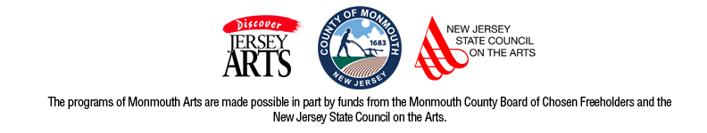

ARTHELPS FISCAL YEAR 2020
MINI GRANT APPLICATION
APPLICANT INFORMATION
Complete all information in the spaces provided. Do not leave blanks.
Applications must be in 12-point font with 1-inch margins and must be completed in full. Handwritten and incomplete applications will be disqualified.
NAME OF ORGANIZATION:
CONTACT PERSON: TITLE:
ADDRESS: CITY: ZIP:
PHONE : FAX:
EMAIL ADDRESS:
PURPOSE OF FUNDING: For publication purposes state in 50 words or less what Monmouth Arts funding will help to support. Begin your statement with “This Monmouth Arts grant will help support…”

TITLE OF PROJECT:

PROJECT INFORMATION - Briefly summarize your project, its goals and objectives. Who is the target audience?

I. PROJECT DESCRIPTION - In greater detail, describe the following:
- What you propose to do and the activities that comprise the project
- How this project meets your organization’s stated mission
- Who will carry out the project, their roles and qualifications
- What benefits the community will derive from this project
II. PROVIDE AN OVERVIEW OF YOUR ARTISTIC AND/OR EDUCATIONAL OBJECTIVES FOR THIS PROJECT

III. EVALUATION - Describe your plans to evaluate the project and its effectiveness in meeting your organizations objectives and mission.
IV. PROJECTED TIMELINE - Provide a timeline for the project including start and completion dates and/or a calendar of when program activities are scheduled.
V. USE OF MINI GRANT FUNDS - Identify the specific project expenses the Mini Grant will be used for. This amount cannot exceed $500.

MINI GRANT PROJECT BUDGET
PLEASE CHECK YOUR MATH!
PROJECT INCOME
CONTRIBUTIONS
Corporate $_________________
Foundation $_________________
Individual Donations $_________________
EARNED INCOME
Admissions $_________________
CASH ON HAND $_________________
MA MINI GRANT $ 500.00
OTHER SUPPORT $_________________

TOTAL PROJECT INCOME $________________

PROJECT EXPENSES
ADMINISTRATION $_________________
ARTISTIC FEES $_________________
OVERHEAD
Telephone $_________________
Utilities $_________________
Postage $_________________
SUPPLIES $_________________
MARKETING/PR
Advertising $_________________
Printing/copying $_________________
OTHER EXPENSES - describe

1._____________________ $_________________
2._____________________ $_________________
3._____________________ $_________________

TOTAL PROJECT EXPENSES $__________________
IN KIND CONTRIBUTIONS - Identify all donated goods and services as well as individual or organizations contributions anticipated, and provide an estimate of cash value.
1._______________________________ $______________________
2. ______________________________ $______________________
3. _______________________________ $______________________
4. _______________________________ $______________________
5 _______________________________ $______________________

SIGNATURE
We certify that the information provided is correct to the best of our knowledge. If awarded a grant, we agree to submit a final report. We will acknowledge Monmouth Arts with its funding statement and logo as a supporter in all advertising, program booklets and press releases.
Signature ______________________________________________________

Title __________________________________ Date __________________

